**Project GenLicensor**

Project Description:

Organizations are serious on software that are used by employees as Unauthorized software might lead to huge fine from the client, hence identifying software valid License, cost, if safe to use is very important for any organization to know. Currently there is no such tool to generate prediction in bulk or individual in compact way. So, this Project will Predict software license and other additional details using generative AI from a given software name with minimum details either from a csv or from the UI.

Predict Software License, versions, price, Approval require for enterprise versions etc

Project Architecture:

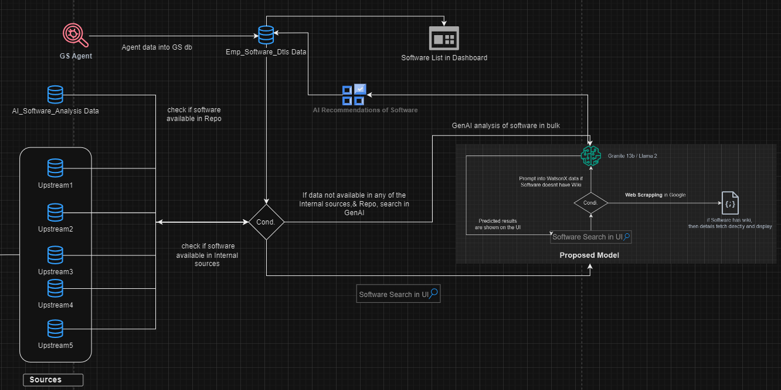

Project codebase Link: