Sentimental Analysis With Gen AI

**Description:**

Sentiment analysis with Generative AI (Gen AI) involves using advanced machine learning models to understand and interpret the emotional tone of text data. Here I have involved granite-13b-chat-v2 model to interpret my project.

**Requirement analysis**

**Objective:** Understanding the customer feedback/opinion on a topic.

**AI Model Selection:** Choose the appropriate Generative AI model or framework based on the complexity of the analysis and the specific needs of the project (e.g., GPT-4, BERT).

**Training Data:** Identify if custom training data is needed for the AI model to improve accuracy in specific contexts or domains.

**Testing Plan:** Develop a plan for testing the sentiment analysis system, including functional, performance, and accuracy tests.

**Functional Requirements**

* **Sentiment Classification:** Specify the types of sentiments to be detected (e.g., positive, negative, neutral).
* **Granularity:** Decide on the level of detail required (e.g., sentence-level, document-level, aspect-level).

**Non-Functional Requirements**

* **Performance:** Set expectations for the system’s performance, including response time and processing speed.
* • **Accuracy:** Define acceptable levels of accuracy and precision for sentiment detection.
* • **Usability:** Consider user interface and experience requirements for those interacting with the sentiment analysis system.

**Project Architecture**

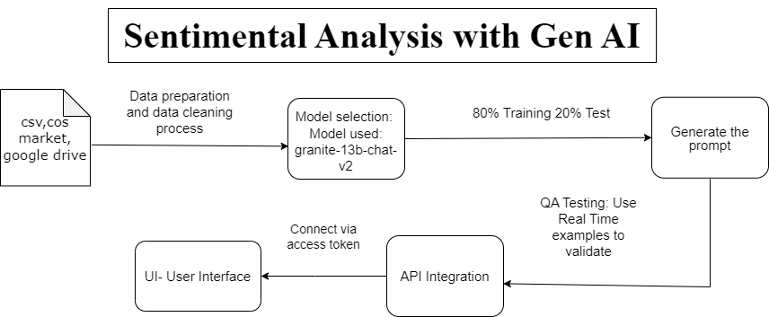

**Project Base Code:**

