The National Institute of Engineering
(Autonomous Institution)

A mini project Report On

“Academic Event Tracker”

Submitted By

Shithij Rai K – 4NI17IS074

Varun Bheemaiah M – 4NI17IS094

Under the guidance of

Internal Guide
Name: Mrs. C K Vanamala
Designation: Associate Professor

External Guide
Name: Mr. Manjit S Sodhi

NIE, Mysore - 8

Department of Information Science and Engineering
MYSORE – 570008
2018 - 2019

TABLE OF CONTENTS

Chapter No. | Chapter | Page No.
1 | Project Details | 1
2 | Workflow | 5

Chapter 1: Introduction

1.1: Objective

The objective of this project was to develop an application to help IBM conduct events in colleges across the country.

1.2: Implementation

In order to achieve the given objective, we decided to create a web application using HTML/CSS (Bulma Framework) for the frontend, Python Flask for the backend and a CouchDB database
The application has 2 types of users:
- Administrators
- SMEs
Each user can login and is presented with a different dashboard depending on the type of user
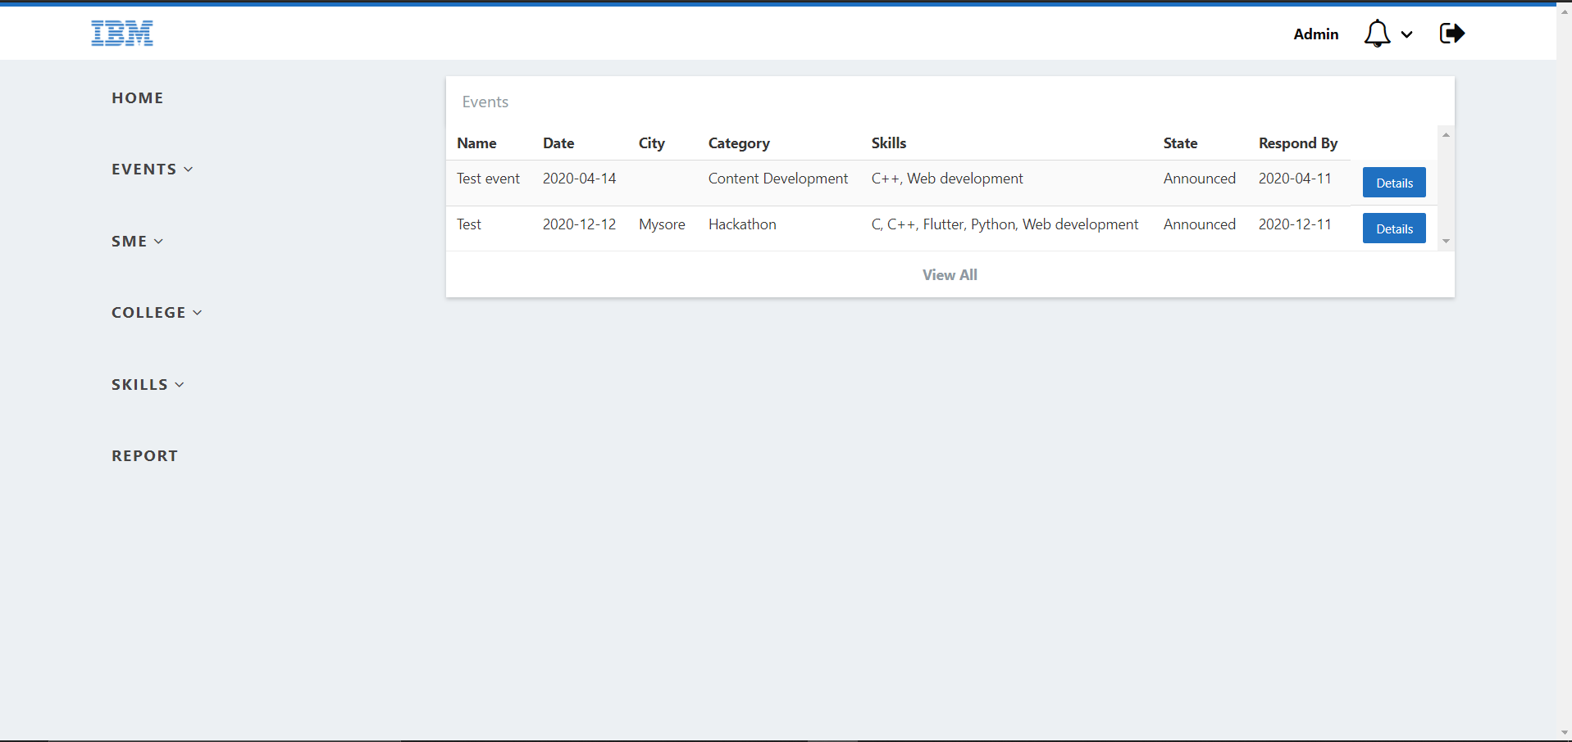
Figure 1: Admin Dashboard
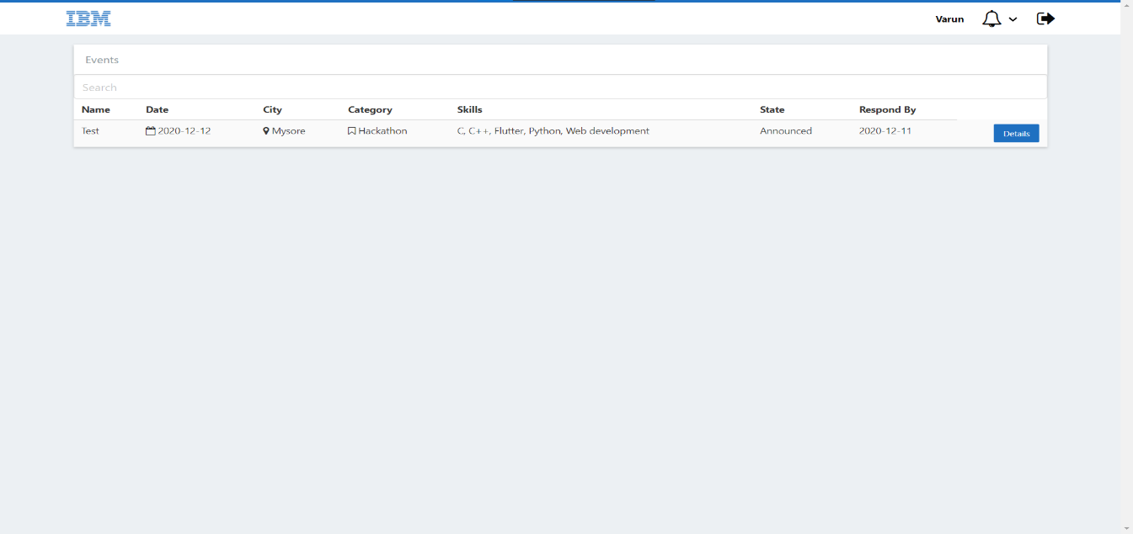
Figure 2: SME Dashboard
From the dashboard, the Admin can perform various operations like
- Creating Events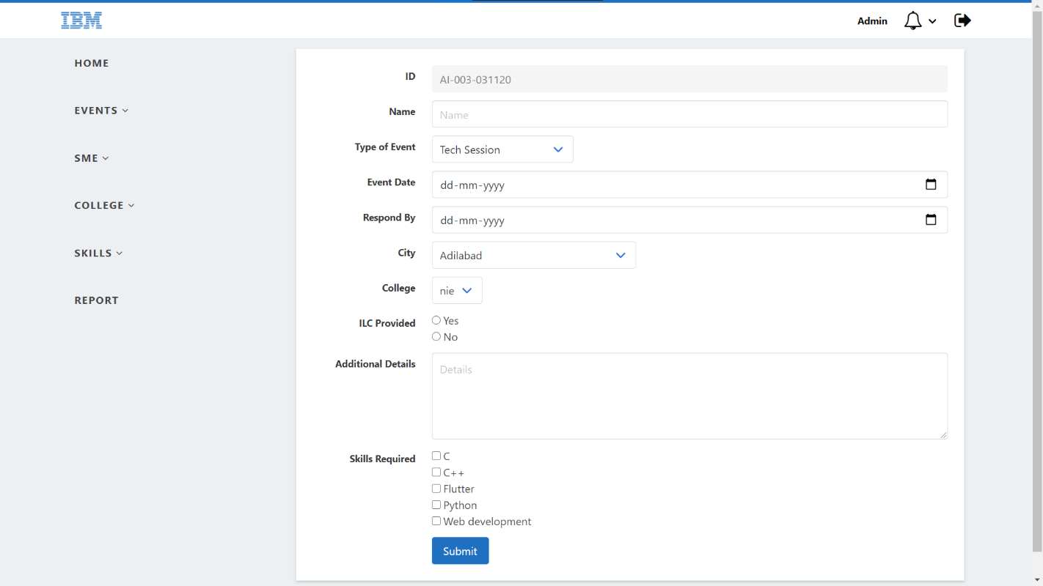
Figure 3: Create Event Page
- Create an SME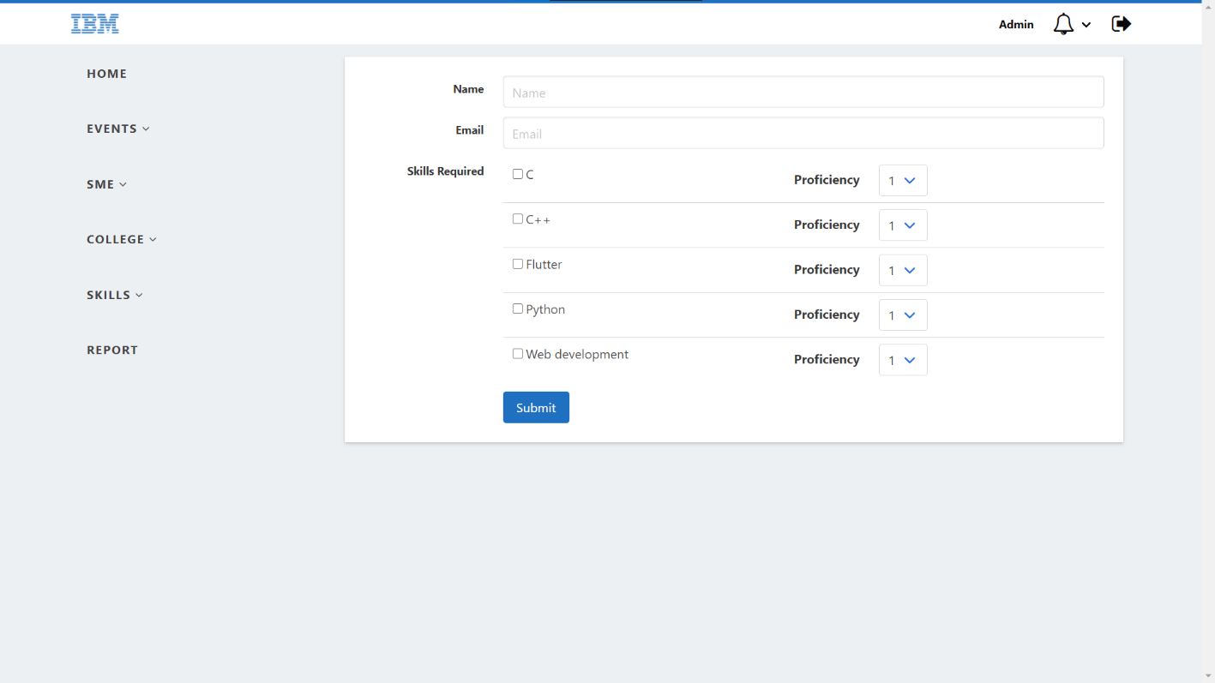
Figure 4: Create SME Page
- Add Skills for an SME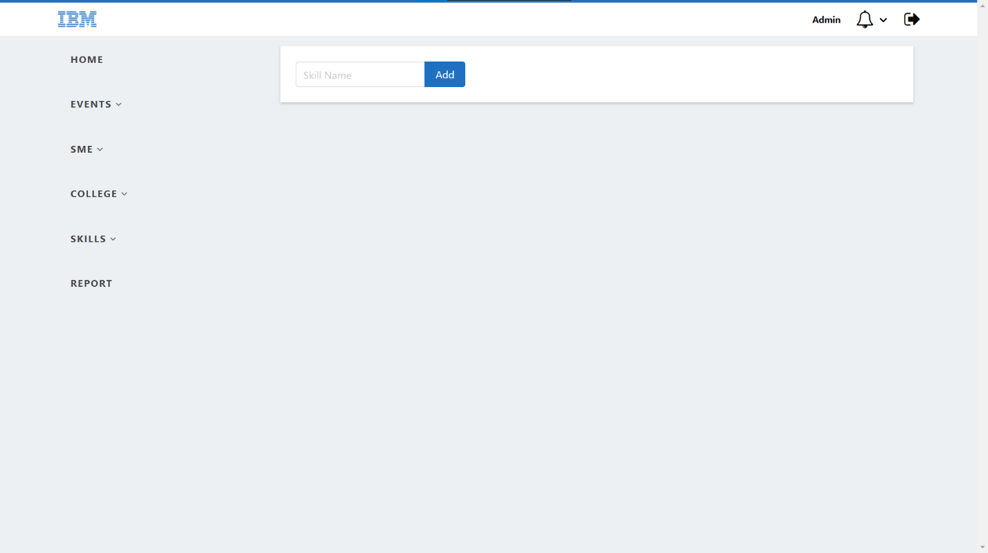
Figure 5: Add Skills Page
- Add Colleges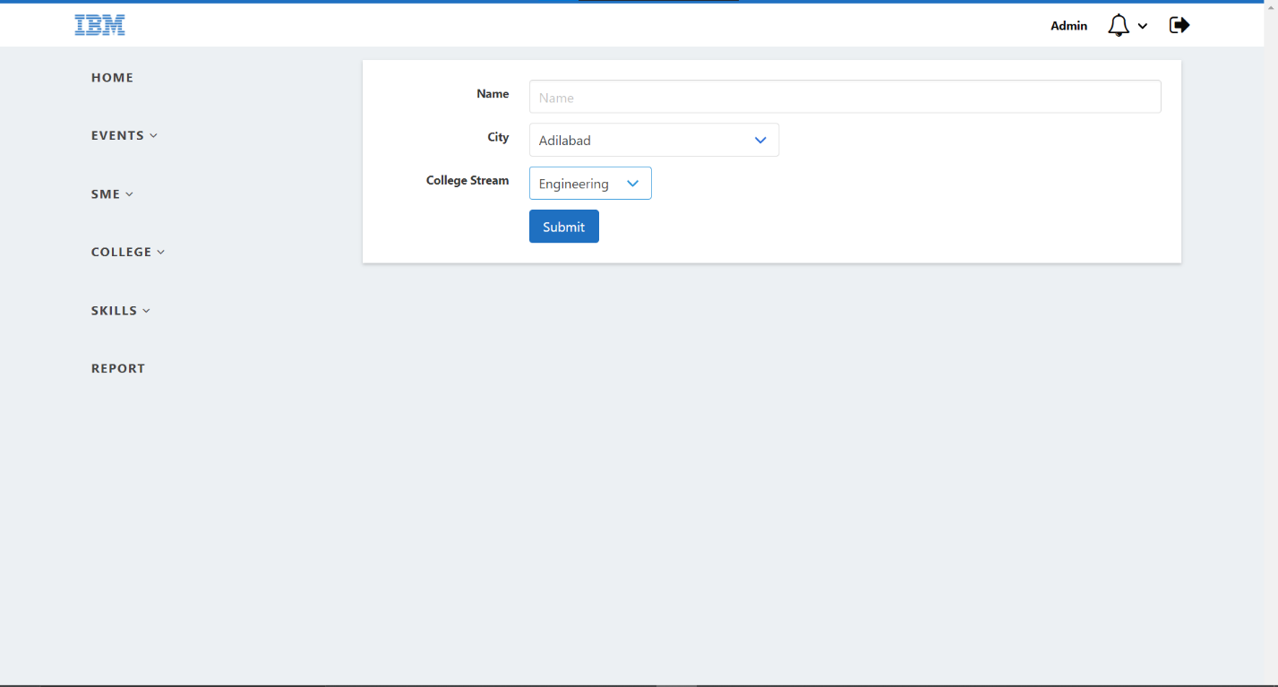
Figure 6: Add Colleges Page
SMEs can perform the following activities
- View Events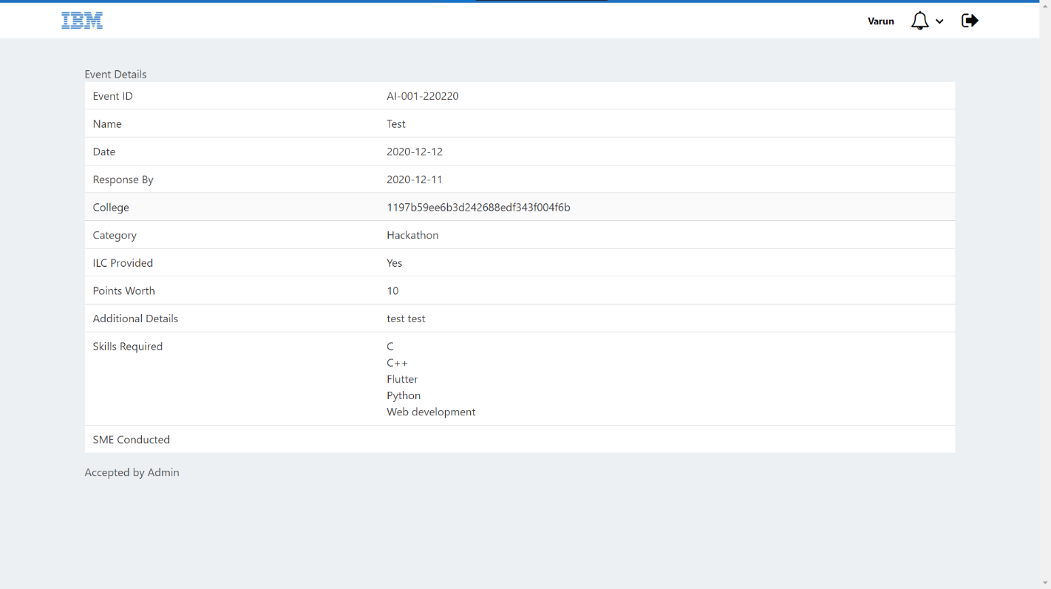
Figure 7: SME View Event
- Register Interest for an event that they were invited for

Admins can also generate reports of the events conducted in any date range
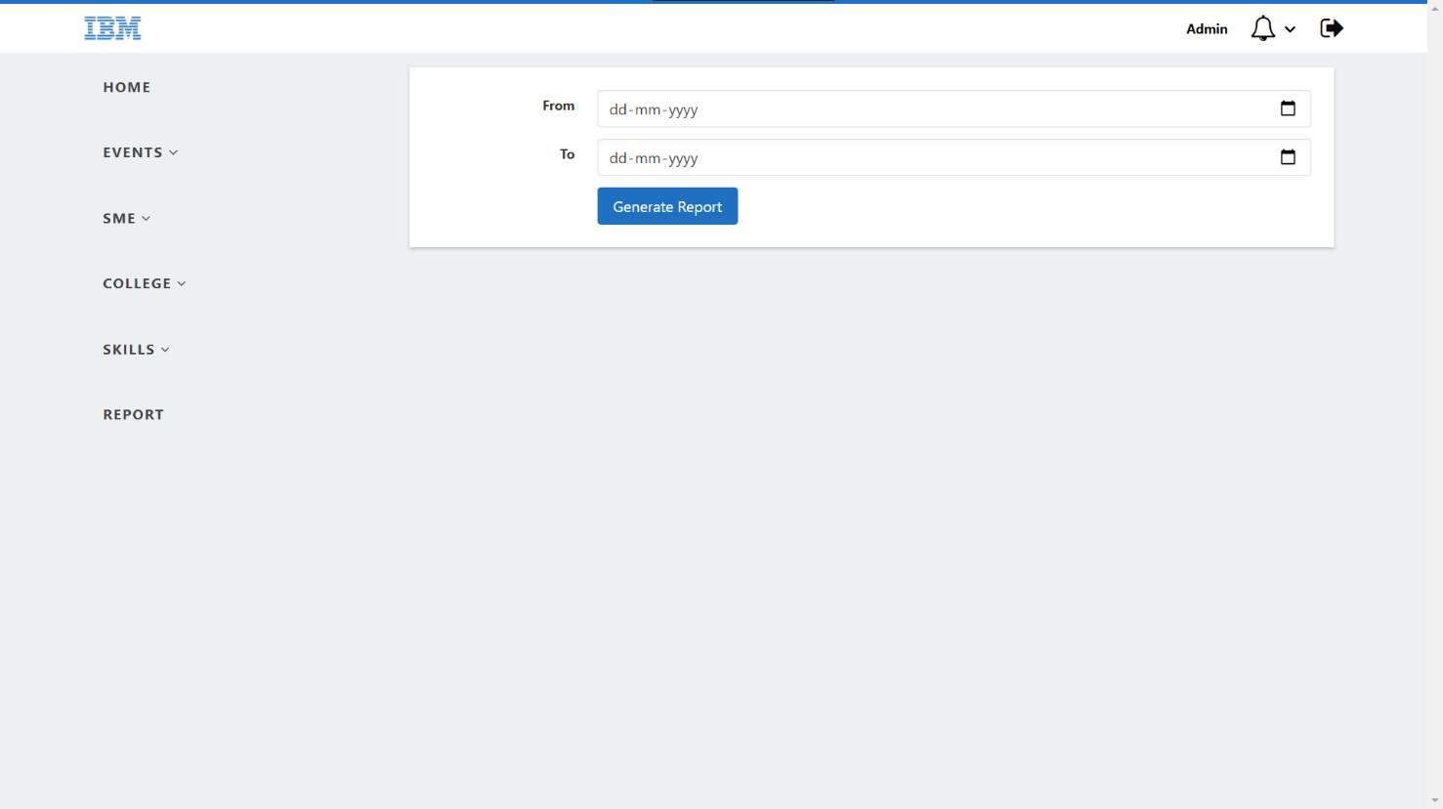

Chapter 2: Workflow

The following is the workflow of the application

